**Energy Savings Report:**

**Richland County, South Carolina**

**Administration Complex**

Energy Efficiency Case Study: A Local Government Example

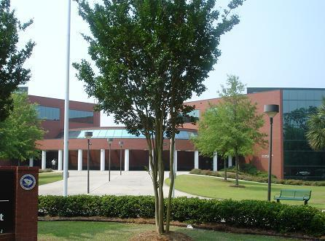

Administration Building

2020 Hampton St, Columbia, SC 29202

803-576-1364

langea@rcgov.us



**Background**

As part of the Energy Efficiency and Community Block Grant (EECBG), Richland County utilized energy efficiency solutions to reduced electricity costs at 2020 Hampton Street. The following upgrades were included in that process: The facility installed T-8 bulbs and ballasts in the interior, added motion and sonic detection switches with master control system to ensure lights are off when area is not occupied, replaced exit signs with LED signs, and replaced parking area exterior lighting with induction lighting and solar cells. Installed 4 virtual servers to replace 22 physical servers, and replaced all refrigerators with ENERGY STAR equipment. All front grounds lighting has been changed to LED from the maintenance budget. This intent was to save power while increasing the actual lighting of the sidewalks.

Richland County uses ENERGY STAR Portfolio Manager to manage the energy consumption of the top 80% of the County’s energy footprint. Staff enters consumption data, cost information, and operational use details that formulate the reports above. The Administration Complex is on target to reducing energy use by 15% using a baseline of 2009. The ENERGY STAR score qualifies the facility for ENERGY STAR certification.

**Quick Facts**

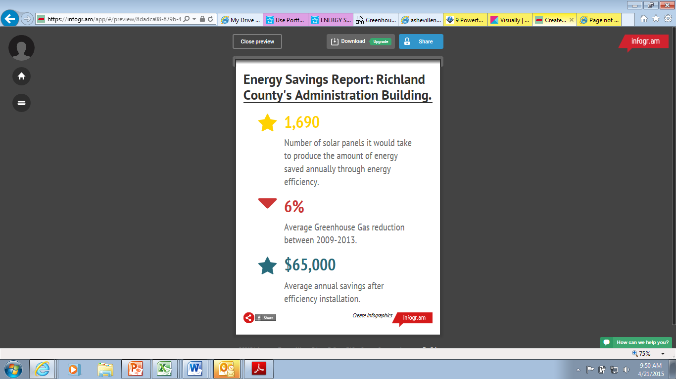

**Energy Star Portfolio Manager Report**

Using Energy Star Portfolio Manager, County staff track the performance of this facility using 2009 as a baseline, before any of the improvements had been incorporated into the facility.

Administration Building

2020 Hampton St, Columbia, SC 29202 | [Map It](http://maps.google.com/?q=2020%20Hampton%20st%2C%20Columbia%2C%20SC%2029202)

Portfolio Manager Property ID: 2231621 | Primarily: [Office](https://portfoliomanager.energystar.gov/pm/glossary#Office)

Year Built: 1992

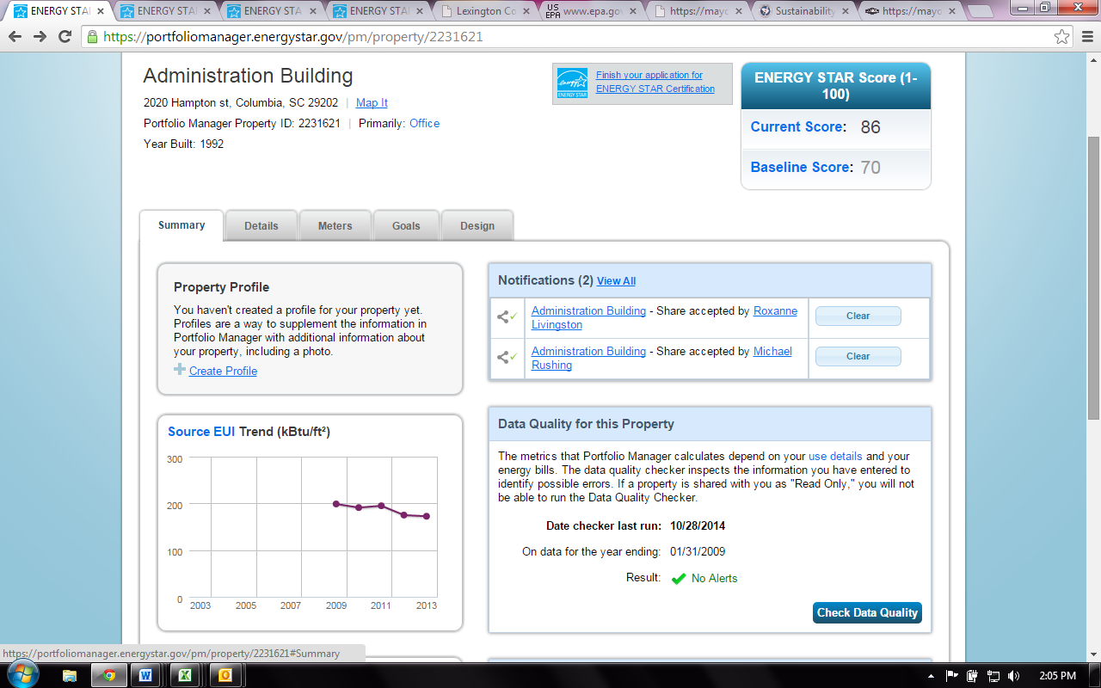



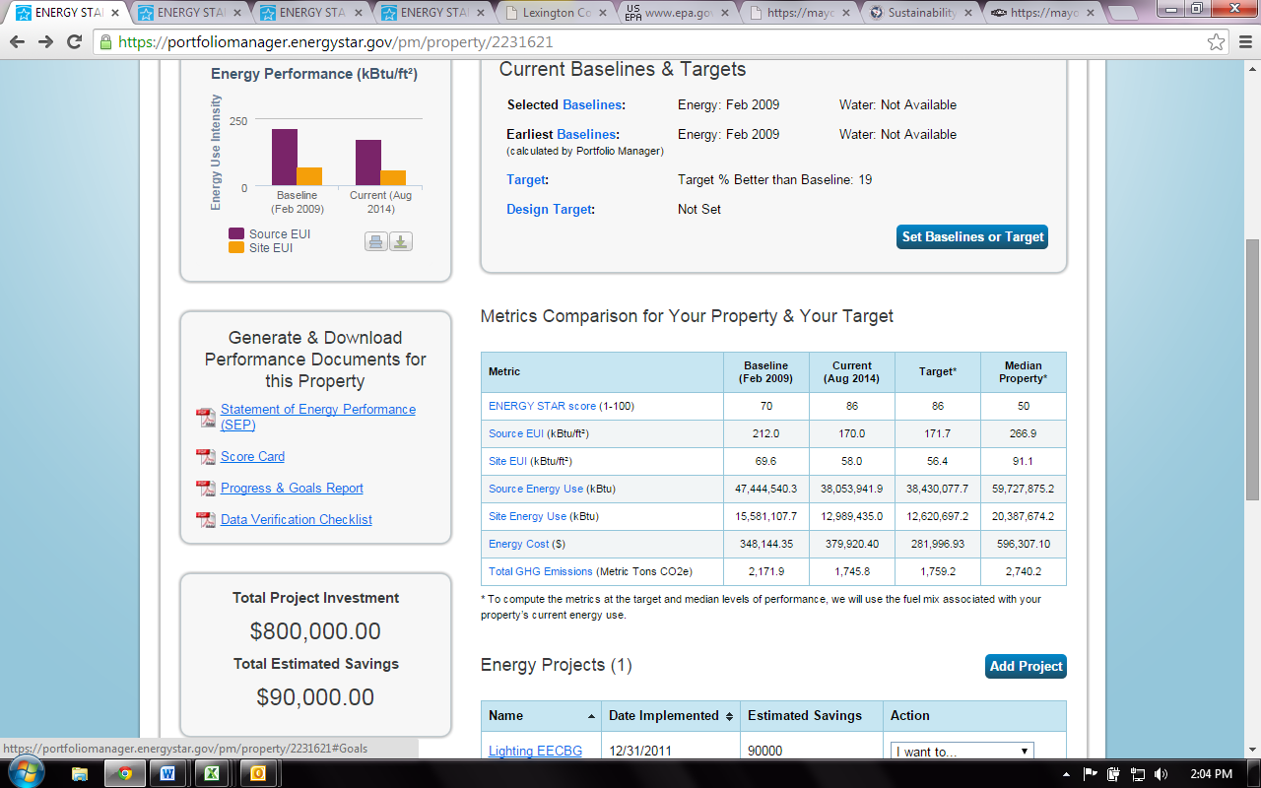

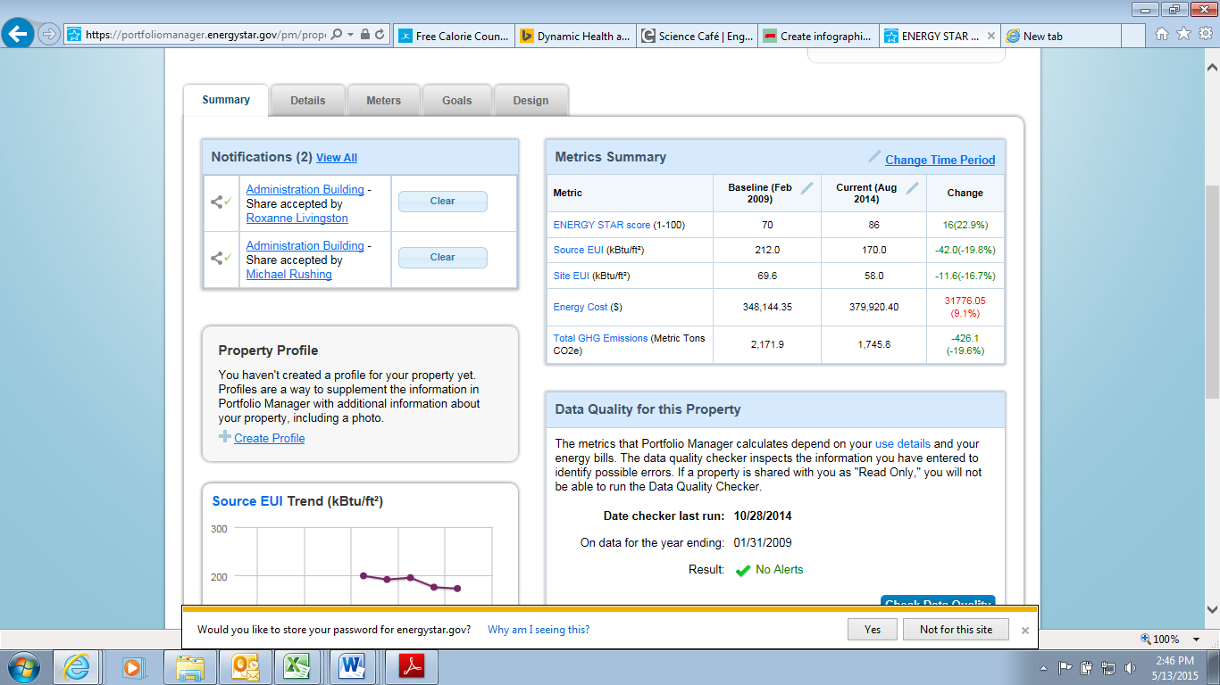

**Simple Payback Calculator**

The funding supported by the lighting upgrades is shown in Figure 1. This simple payback is calculated below as a point of reference. These upgrades were 100% grant funded without using county dollars, all of the savings is captured by the county.

|  |  |
| --- | --- |
| **Building** | Administration Building |
| **Implementation Date** | 2011 |
| **Grant Funding** | $760,320.00 |
| **Annual Savings Estimate** | $65,000.00 |
| **Simple payback** | 11 yrs |

Figure 1

**Rate Structure Increases**

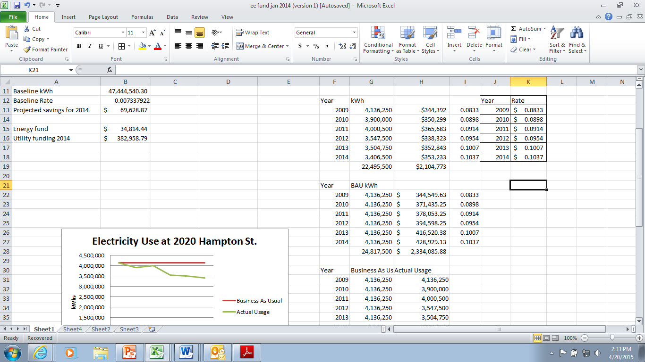

Figure 2

Figure 2 shows the rate increases between from 2009 – 2014 from South Carolina Electric and Gas (SCE&G). Electrical usage at the Hampton St. complex decreased by about 25% between 2009-2014. These are based on January - December usage for each year.

**Metric Calculations**

**Electricity Usage 2009 - 2014**

Figure 3

Due to energy efficiency investments the administration complex has reduced energy use by 2,322,000kWh from 2009-2014. Most of the work was not completed until 2012, which is apparent from the drop in usage in 2012 on the graph. There was an 18% reduction in usage in 2014 as compared to the baseline or 729,750 kWh. It would take 1,690 310Watt solar panels to produce the same about of energy that is saved through efficiency.

**Electricity Costs 2009 - 2014**

Figure 4**This Total Cost does not include Franchise Fee or Sales Tax

This chart compares the cost of operating 2020 Hampton St. without any energy efficiency upgrades. This assumes this building would operate using a business as usual model, taking into account rate increases without energy reductions strategies. The Actual scenario shows that building operations have been reduced by the energy efficiency upgrades. The upgrades have allowed the costs to stabilize over the last five years. This accounts for over $229,000 is savings between 2009-2014. This accounts for a 10% average reduction in costs as compared to business as usual.

**GHG Emissions 2009 - 2014**

Figure 5

Figure 5 shows greenhouse gas emissions for 2020 Hampton Street. There was a 13%reduction in Greenhouse Gas (GHG) emissions in 2013 as compared to the baseline. The sum of the greenhouse gas emissions is equivalent to:

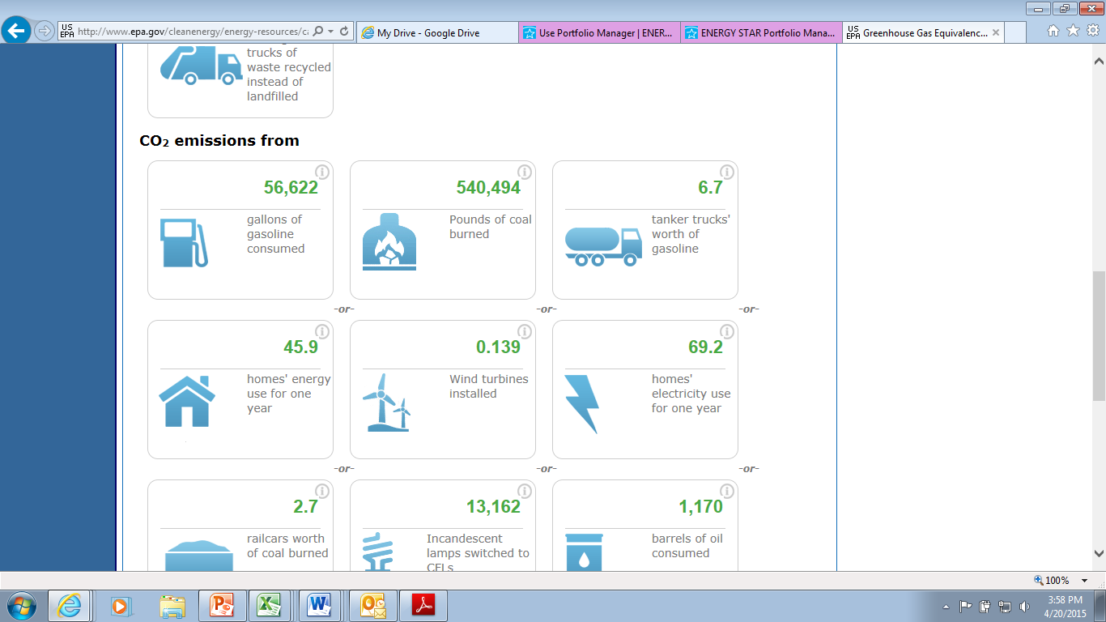 *or  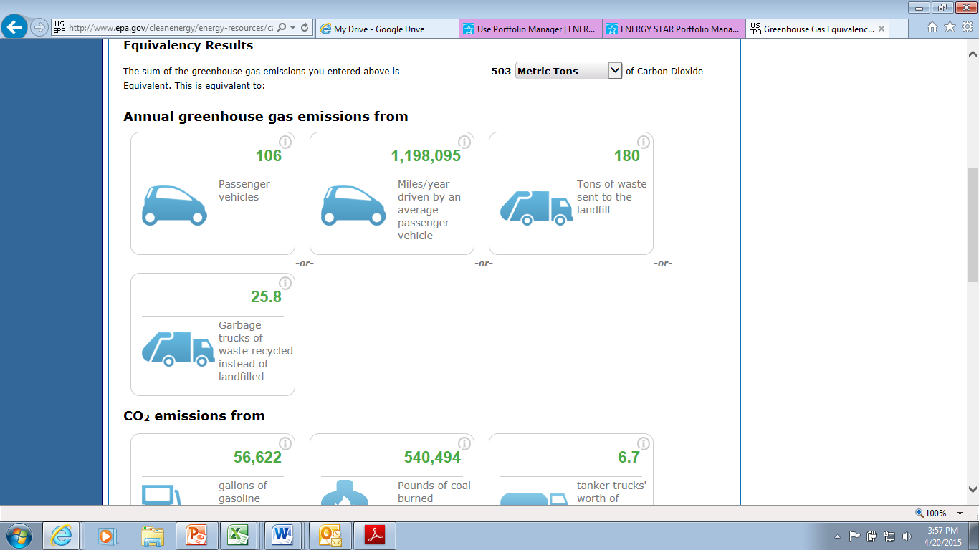 or* 

**Results**

The numbers show that energy efficient lighting upgrades will have a 11 year return on investment (ROI). The building is on target to meeting the 15% energy reduction goal and more. Investing in energy efficiency for 2020 Hampton has yielded the predicted results.

Recommendations:

The $65,000 in annual savings from this program can be used to support additional energy efficiency programs for facilities. The best way for the County to meet its sustainability goals is to create Green Capital Improvement Plan (Green CIP). A Green CIP captures the savings from each project and deposits them in a capital improvements account whose funds can roll from one year to the next, these savings finance future initiatives.

Capturing savings like this to support future energy efficiency project is a model that is used often, but not currently in use at Richland County, SC. A Green CIP can reduce maintenance and operating costs while building a return on investment model to finance sustainability initiatives through energy savings.

Staff recommends funding energy efficiency projects such as energy efficient lighting, HVAC upgrades, water efficiency through the Green CIP, that have a defined return in investment, through power reductions and reduced maintenance cost. These energy improvements have a direct reduction, not only in cost to operate and maintain, but our carbon footprint as well. In fact, each dollar invested in electric energy efficiency measures yields $1.24 to $2.00 in avoided energy on average.

Another financing strategy is reserving funding annually through the County’s bonding capacity to fund energy efficiency and clean energy projects creates an avenue to proactively upgrade aging infrastructure and comply with the High Performance Building Policy. Project requests will be reviewed by staff to include the Capital Improvements Projects Manager, Support Services, and Sustainability. Projects will then be prioritized based on factors such as return on investment, project cost, and energy/fuel reduction. A green capital improvement program has the added benefit of recycling energy savings to fund additional energy investments, equipment upgrades, and fuel reduction measures.

**Definitions**

#### Energy Cost

The energy cost is the annual cost associated with the selected 12 month time period for a property or building. Energy cost is available for each individual energy type and also as an aggregated value across all energy types.

#### ENERGY STAR Score

#### The ENERGY STAR Score is a measure of how well your property is performing relative to similar properties, when normalized for climate and operational characteristics. The ENERGY STAR scores are based on data from national building energy consumption surveys, and this allows Portfolio Manager to control for key variables affecting a building’s energy performance, including climate, hours of operation, and building size. What this means is that buildings from around the country, with different operating parameters and subject to different weather patterns, can be compared side-by-side in order to see how they stack up in terms of energy performance. The specific factors that are included in this normalization (Hours, Workers, Climate, etc) will depend on the property type. The 1-100 scale is set so that 1 represents the worst performing buildings and 100 represents the best performing buildings. A score of 50 indicates that a building is performing at the national median, taking into account its size, location, and operating parameters. A score of 75 indicates that at a property is performing in the 75th percentile and may be eligible to earn [ENERGY STAR Certification](https://portfoliomanager.energystar.gov/pm/glossary#EnergyStarCertification). GHG Emissions

Greenhouse Gas (GHG) Emissions are the carbon dioxide (CO2), methane (CH4), and nitrous oxide (N2O) gases released into the atmosphere as a result of energy consumption at the property. GHG emissions are expressed in carbon dioxide equivalent (CO2e), a universal unit of measure that combines the quantity and global warming potential of each greenhouse gas. Emissions are reported in four categories, each is available as a total amount in metric tons (Metric Tons CO2e) or as an intensity value in kilograms per square foot (kgCO2e/ft2):

#### Site Energy

Site Energy is the annual amount of all the energy your property consumes onsite, as reported on your utility bills. Use site energy to understand how the energy use for an individual property has changed over time.

**Source Energy**

Source Energy Use is the total amount of raw fuel that is required to operate your property. In addition to what the property consumes on-site, source energy includes losses that take place during generation, transmission, and distribution of the energy, thereby enabling a complete assessment of energy consumption resulting from building operations. For this reason, Source EUI is the best way to quantify the energy performance of commercial buildings. Use it to understand the complete energy impact of your property, and to compare the energy performance

of properties across your portfolio.

#### Target Values

Target Values are the performance metrics associated with an established target (goal) for your property. Portfolio Manager has both a regular target and a target for the property design. The target values are listed as 15% above the baseline.

Prepared by Anna Lange

Sustainability Manager

Richland County

803-576-1364

langea@rcgov.us